**[Why Amazon Has No Profits (And Why It Works)](http://ben-evans.com/benedictevans/2014/9/4/why-amazon-has-no-profits-and-why-it-works)**

[September 05, 2014](http://ben-evans.com/benedictevans/2014/9/4/why-amazon-has-no-profits-and-why-it-works)

*(I also did a podcast with Ben Horowitz discussing these themes:*[*see here*](http://ben-evans.com/benedictevans/2014/9/5/podcast-amazon)*)*

Amazon has a tendency to polarize people. On one hand, there is the ruthless, relentless, ferociously efficient company that’s building the Sears Roebuck of the 21st Century. But on the other, there is the fact that almost 20 years after it was launched, it has yet to report a meaningful profit. This chart captures the contradiction pretty well - massive revenue growth, no profits, or so it would seem. But actually, neither of these lines gives you a good sense of what’s really going on.

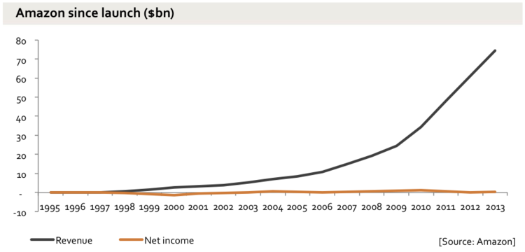

Amazon discloses revenue in three segments - Media, Electronics & General Merchandise (‘EGM') and ‘Other’, which is mostly AWS. As this chart shows, these look very different (this and most of the following ones use ’TTM’ - trailing 12 months, which smooths out the seasonal fluctuations and makes it easier to see the underlying trends). The media business is still growing, but it’s the general merchandise that has powered the explosion in revenue in the past few years. Meanwhile, the ‘Other' line is growing but is still much smaller.

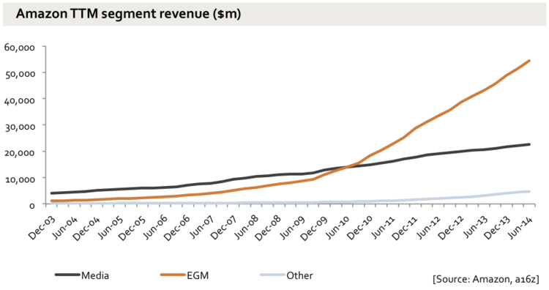

Splitting out the detail, we can see this trend both in North America (NA) and internationally...

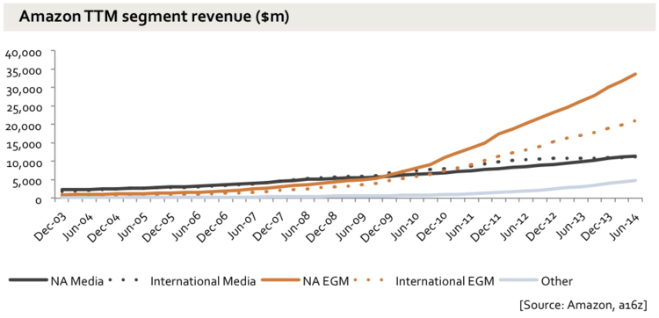

Though the takeoff is particularly strong in the USA.

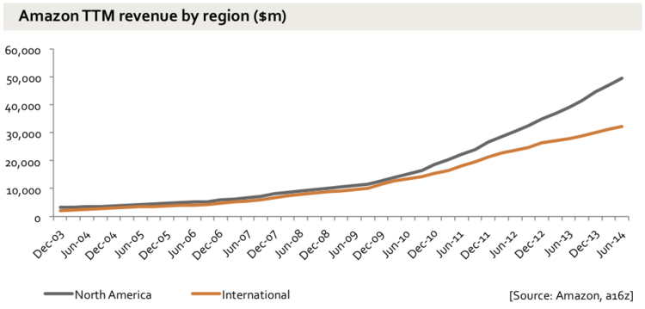

Media overall was only 25% of Amazon’s revenue last quarter, and 20% of North America.

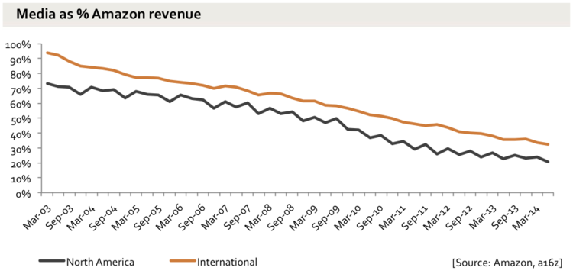

And if we go back to ‘Other’ and zoom in, the growth is pretty dramatic there too.

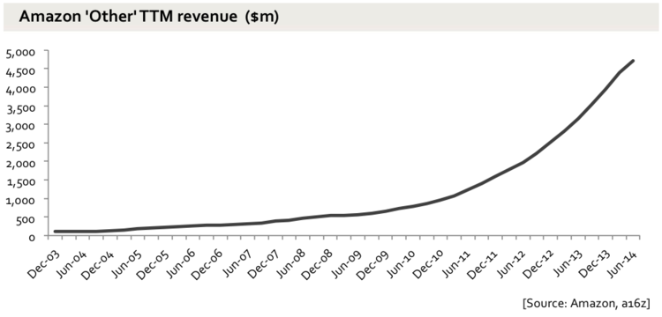

It seems pretty likely that these businesses, selling very different products bought with different bargaining positions to different people with different shipping costs, have different margin potential.

This still doesn’t really give an accurate picture, though. Amazon is in fact organized not just in these segments, but in dozens and dozens of separate teams, each with their own internal P&L and a high degree of autonomy. So, say, shoes in Germany, electronics in France or makeup in the USA are all different teams. Each of these businesses, incidentally, sets its own prices. Meanwhile, all of these businesses are at different stages of maturity. Some are relatively old, and well established, and growing slower, and are profitable. Others are new startups building their business and losing money as they do so, like any other new business. Some are very profitable, and some sell at cost or at as loss-leaders to drive traffic and loyalty to the site. Books are a good example. There’s a widespread perception that Amazon sells books at a loss, but the average sales price actually seems to be very close to physical retailers - it discounts some books, but not all, and despite all the argument in the Agency lawsuits, quite how many and how much is (deliberately) as clear as mud.

Amazon is a bundle.

The clearest  expression of this is Prime, in which (amongst other things) entertainment content is included at a high fixed cost to Amazon (buying the rights) but no marginal cost beyond bandwidth, as a way to enhance the appeal of being a Prime ‘member'. Prime membership in turn draws people to switch more and more of their online and offline spending to Amazon. Trying to look at the profitability of the video alone misses the point.

And then there are the third party sales. Just as AWS is a platform both for Amazon's own internal technologies and for thousands of startups, so too the logistics and commerce infrastructure themselves are a platform for lots and lots of different Amazon businesses, and also for lots of other companies selling physical products through Amazon’s site. Third party sales of products through Amazon’s own platform are now 40% of unit sales, and the fees charged to these vendors are now 20% of Amazon’s revenue.

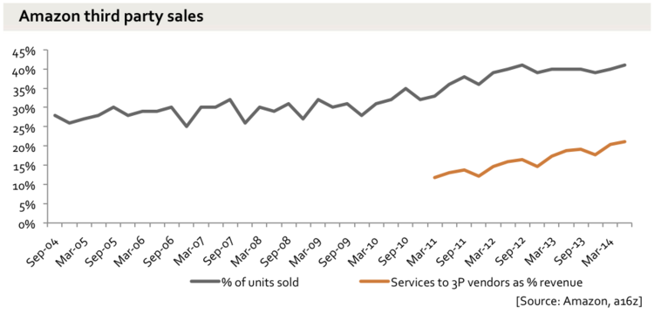

This means, in passing, that for close to half of the units sold on Amazon.com, Amazon does not set the price, it just takes a margin. This alone should point to the weakness of the idea that Amazon’s growth is based on selling at cost or at a loss.

The tricky thing about these third party (‘3P’) sales is that Amazon only recognizes revenue from the services it provides to those companies, not the value of the goods sold. So if you buy a pair of shoes on Amazon from a third party, Amazon might collect payment through your Amazon account and ship them from its warehouse using its shipping partners - but only show the shipping and payment fees it charged to the shoe vendor as revenue. It does not disclose the gross revenue (‘GMV’). Given that (as it does disclose) third party sales tend to have a higher unit value, this means that the total value of goods that pass though Amazon with Amazon taking a percentage is perhaps double the revenue that Amazon actually reports. So, the revenue line is not really telling you what's going on, and this is also one reason why gross margin is pretty misleading too. Gross profit has risen from 22.4% in 2011 to 27.2% in 2013, but this does not really reflect a change in consumer pricing and margins thereof, but rather this change in mix.

So, we have dozens of separate businesses within Amazon, and over two million third party seller accounts, all sitting on top of the Amazon fulfillment and commerce platform. Some of them are mature and profitable, and some are not. And someone at Amazon has the job of making sure that each quarter, this nets out to as close to zero as possible, at least as far as net income goes. That is, the problem with net income is that all it tells us is that every quarter, Amazon spends whatever’s left over to get the number to zero or thereabouts. There’s really no other way to achieve that sort of consistency.

If you listen closely, Amazon itself tells us this. The image below comes straight from Amazon - originally it was a napkin sketch by Jeff Bezos. Note that there’s no arrow pointing outwards labeled  'take profits.’ This is a closed loop.

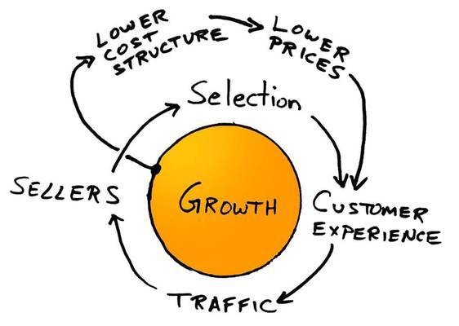

(Source: Amazon)

In any case, profits as reported in the net income line are a pretty bad way to try to understand a business like this - actual cash flow is better. As the saying goes, profit is opinion but cash is a fact, and Amazon itself talks about cash flow, not net income (Enron, for obvious and nefarious reasons, was the other way around). Amazon focuses very much on free cash flow (FCF), but it’s very useful to look also at operating cash flow (OCF), which is simply what you get adding back capital expenditure (‘capex'). In effect, OCF is the bulk of  running the business before the costs of the infrastructure, M&A and financing costs. This shows you the effect of selling at low prices. As we can see here, Amazon’s OCF margin has been very roughly stable for a decade, but the FCF has fallen, due to radically increased capex.

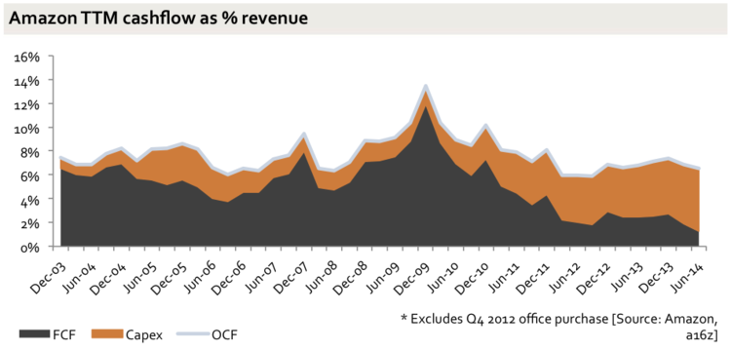

In absolute terms, you can therefore see a business that is spinning out rapidly growing amounts of operating cash flow - over $5bn in the last 12 months - and ploughing it back into the business as capex.

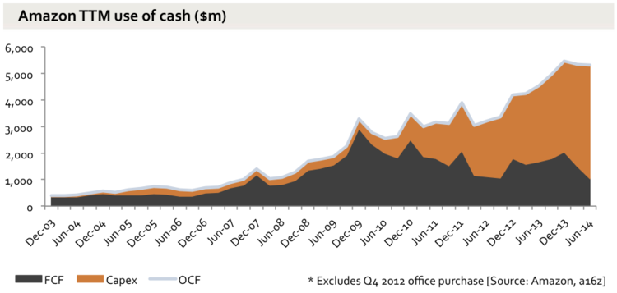

Charting this as lines rather than areas shows just how consistent the growth in capex has been.

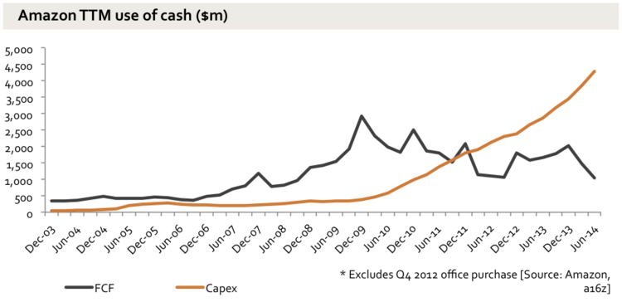

One might suggest that in a logistics business with rapid revenue growth, rapid capex growth is only natural, and one should look at the ratio of capex to sales by itself. But in fact, the increase here is even more dramatic. Starting in 2009, Amazon began spending far more on capex for every dollar that comes in the door, and there’s no sign of the rate of increase slowing down.

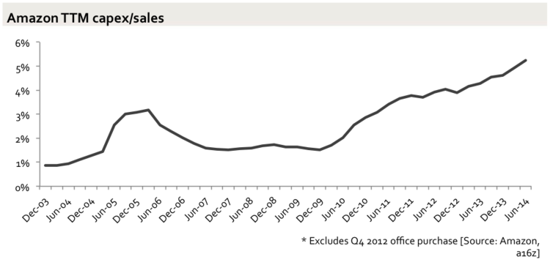

If Amazon had held capex/sales at the same ratio from 2009, before it exploded, then FCF would look like this. That difference adds up to just over $3bn of cash in the last 12 months. That is, if Amazon was spending the same on capex per dollar of revenue as it was in 2009, it would have kept $3bn more in cash in the last 12 months.

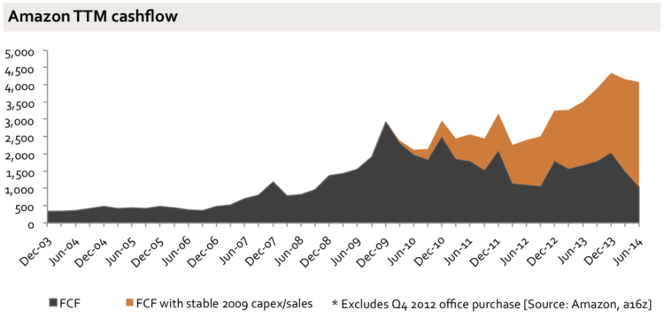

So where’s all the extra capex going? And, crucially, does it need to stay at these new, higher levels to support Amazon's business, or can it come back down in the future?

It’s pretty apparent that the money is going into more fulfillment capacity (warehouses, to put it crudely) and to AWS. Hence, this chart shows an enormous increase in Amazon’s physical infrastructure, as measured in square feet - this is almost all fulfillment rather than data centers, though Amazon no longer gives a split.

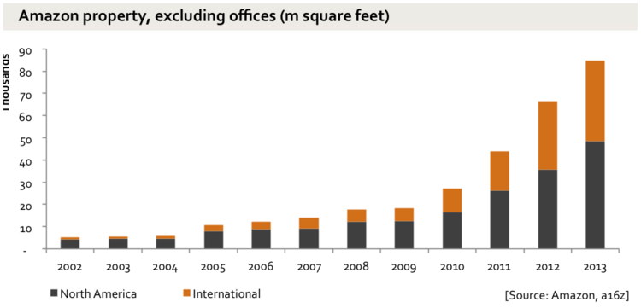

Pulling apart precisely where the money's going, though, is a little fiddlier. The increase is driven by some combination of four things:

1. More capacity for more products, including 3P products
2. Proximity - as Amazon builds warehouses closer to customers, the shipping time goes down and so too does the shipping cost, a further flywheel effect for Prime
3. AWS
4. More expensive warehouses - that is, the existing business is becoming more expensive to run

The first two of these are straightforward investment in the future, often delivering higher future margins. AWS is a black box and a much debated puzzle, but it is also pretty much the definition of a new business that requires investment to grow. The real bear case here would be the last point - that the existing business is becoming more capex-intensive - that more dollars of capex are needed for every dollar of current revenue.

Just to make life harder for those looking to understand Amazon’s financials, the warehouse expansion, capex expansion and AWS build-out all started at roughly the same time, and at that same moment Amazon changed the way it reports to make it very hard to pick them apart. Until 2010 it split both property and asset value between fulfillment and data centers, but at that point it stopped, probably not by co-incidence (in 2010 Amazon had just 775k square feet for data centers and customer service combined). In the meantime, there are various metrics (capex per square foot, for example) that would show a shift of spending from cheap warehouse to expensive data centers - but they would also show a shift from maintaining existing warehouses to building new ones. So there is no direct, easy way we can see the split.

We can still, though, get a something of a sense of the key warehouse question - has the business got more expensive to run? It looks like the answer is no. First, the third party sales do not seem to be the issue: ratio of 3P units has not gone up at anything like the way the capex/sales has over the same period (here’s that chart again).

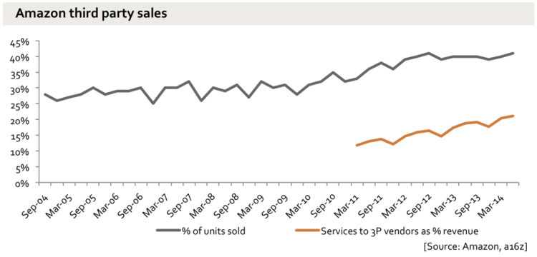

Neither is there any sign of a shift in the fulfillment costs over the period (Amazon seems to have forgotten to stop disclosing these). The physical product mix hasn’t got dramatically more expensive to ship, so would it get dramatically more capex-intensive to warehouse? This is obviously not an exact proxy, but it seems unlikely.

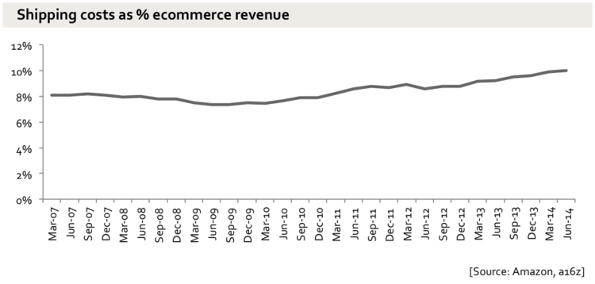

So, though we can’t be sure, it looks like the capex is *not* going up because Amazon’s existing business has become more expensive to run, but because Amazon is investing the growing pool of operation cash flow into the future. All of this brings us back to the beginning - Amazon’s business is delivering very rapid revenue growth but not accumulating any surplus cash or profits, because *every penny of cash* is being ploughed back into expanding the business further. But, this is not because any given business runs permanently at a loss - it is because the profits from what is already there are spent on making new businesses. In the past, that was mostly in operations, but in recent years the investment firehose has again been pointed at capex.

How long will this investment go on for? Well, do we believe that the conversion of products and businesses to online commerce is finished? Let’s rebase that revenue chart, and look at it as share of US retail revenue. Excluding gasoline, food and things like timber and plants,all hard to ship, at least for now, Amazon has about 1%.

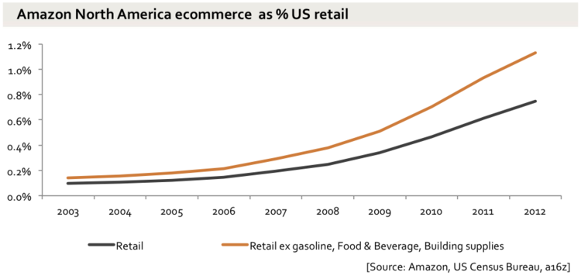

Overall, US commerce is growing very consistently:

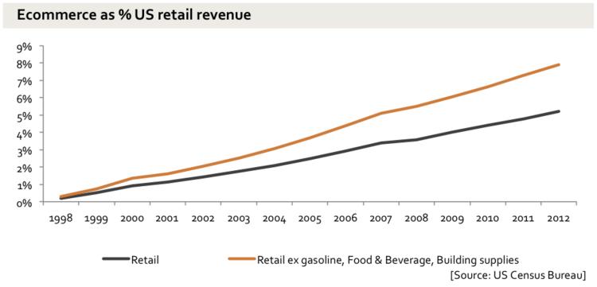

And Amazon is taking an accelerating share of it.

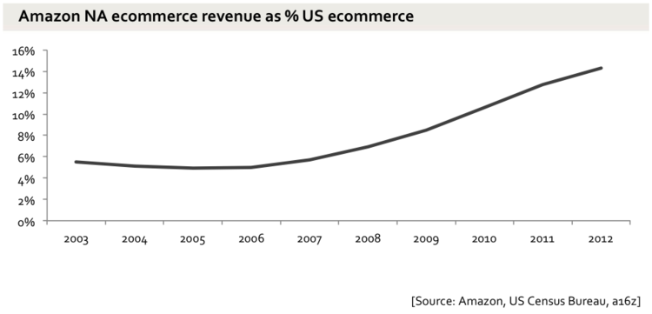

Amazon has perhaps 1% of the US retail market by value. Should it stop entering new categories and markets and instead take profit, and by extension leave those segments and markets for other companies? Or should it keep investing to sweep them into the platform? Jeff Bezos’s view is pretty clear: keep investing, because to take profit out of the business would be to waste the opportunity. He seems very happy to keep seizing new opportunities, creating new businesses, and using every last penny to do it.

Still, investors put their money into companies, Amazon and any other, with the expectation that at some point they will get cash out.  With Amazon, Bezos is deferring that profit-producing, investor-rewarding day almost indefinitely into the future. This prompts the suggestion that Amazon is the world's biggest 'lifestyle business' - Bezos is running it for fun, not to deliver economic returns to shareholders, at least not any time soon.

But while he certainly does seem to be having fun, he is also building a company, with all the cash he can get his hands on, to capture a larger and larger share of the future of commerce. When you buy Amazon stock (the main currency with which Amazon employees are paid, incidentally), you are buying a bet that he can convert a huge portion of all commerce to flow through the Amazon machine. The question to ask isn’t whether Amazon is some profitless ponzi scheme, but whether you believe Bezos can capture the future. That, and how long are you willing to wait?